

Analysis of Song Duration and Popularity Across Musical Genres

JULY 1, 2024



**GROUP MEMEBERS**

* **Quinta Achieng FAB/DV/01**
* **Otieno Lilian FAB/DV/07**
* **Rhoda Kiige FAB/DV/08**
* **Branice Awino FAB/DV/06**
* **Leah Achieng FAB/DV/09**
* **Daniel Habil FAB/DV/031**

**Music Genre Analysis Report**

**Overview:**

This report summarizes the popularity, release count, and duration statistics of various music genres over two decades. The analysis provides insights into trends and patterns across different genres, helping to understand changes in the music landscape.

**Release Summary (Count of Releases by Genre)**

**First Decade Release Summary (Count of Releases by Genre)**

**Second Decade Release Summary (Count of Releases by Genre):**

**Combined Release Summary (Count of Releases by Genre)**

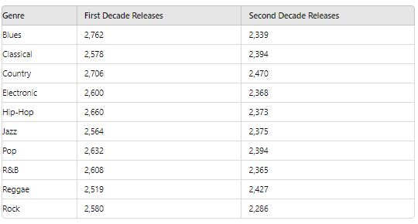

**Conclusion**

The number of releases for all genres decreased in the second decade compared to the first. Blues saw a significant drop from 2,762 to 2,339 releases, while Classical and Country also experienced declines to 2,394 and 2,470 releases, respectively. Pop and Hip-Hop had slight decreases, and Rock experienced a notable decrease from 2,580 to 2,286 releases.

**Recommendation**

* Enhance audience engagement through social media, live performances, and other interactive platforms to maintain and grow interest in various genres.
* Provide more support and resources for artists, particularly in genres that have seen a decline, to encourage more releases and creativity.

**Popularity Summary (Sum of Popularity by Genre)**

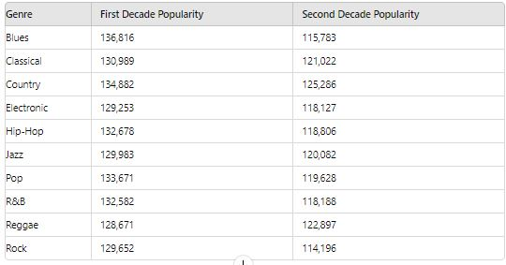

**Conclusion**

The total popularity scores for all genres decreased in the second decade compared to the first. Blues: Experienced a significant decrease in popularity from 136,816 to 115,783. Classical and Country: Both saw a decline, with Classical reducing to 121,022 and Country to 125,286. Pop and Hip-Hop: Both genres also saw declines, with Pop dropping to 119,628 and Hip-Hop to 118,806. Reggae: Experienced a lesser decline in popularity compared to other genres.

**Recommendation**

* Strengthen marketing efforts for genres with significant declines to revitalize their popularity.
* Invest in understanding and leveraging current music trends and consumer behaviors to boost genre popularity.

**Duration Summary (Duration by Popularity)**

df.head(20)

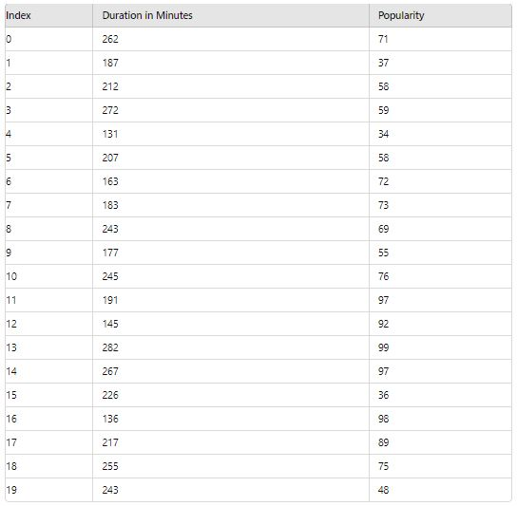

Conclusion

* On average, the duration of the content is about 209.74 minutes. This indicates that most of your content is relatively long, though there is variability in individual durations.
* On average, the popularity score is around 50.26. This suggests a moderate level of engagement or interest in the content.

Recommendation

* Identify factors that contribute to higher popularity. Analyze the characteristics of content with above-average popularity and apply similar strategies to other content.
* Continuously monitor and analyze both duration and popularity to identify trends and make data-driven adjustments to content strategy.

**Duration Summary (Duration by Genre)**

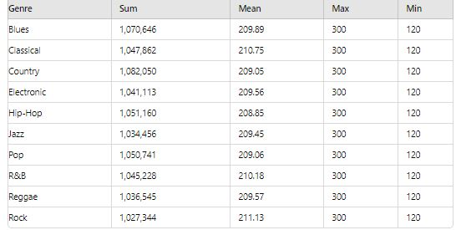

Conclusion

The average duration are quite close to each other, suggesting that content length is relatively uniform across genres.

The maximum duration of 300 minutes is consistent for all genres, which could indicate a standard or ceiling for content length.

Recommendation

* Given the consistency in average duration, content strategies can be genre-specific if certain genres benefit from longer or shorter formats.
* To optimize content, consider exploring other attributes like engagement or popularity specific to each genre.